Frequency Hopping:
How is communication setup ? : The Transmitter sends a signal at a particular frequency and then a band pass filter is applied such that it receives only that signal
Next task:
Continously changing the frequency of the communication between the two drones
How is that possible :
FHSS : Frequency Hopping Spread System
In this, based on an alogorithm the frequency at which the communication will be done is calculated using an algorithm . The algorithm is basically a function which runs on both the transmitter and the receiver end and thus it generates the same frequency each time and thus both know at what frequency the communication is going to happen but the surroundings don’t have a idea abt it
For this two things are important
What is the starting value?
After how much time do we have to change the frequency?
The transmitter sends a sync packet on a predetermined channel , Control Channel to the receiver and the sync packet contains the seed or the starting value .
After how much time to change the frequency is also precoded inside both the transmitter and the receiver but the starting point is dynamic .
How do we determine the starting point?
In each packet sent , there is also a sync packet , when the receiver receives the packet it sets the timer to zero , here the propogation delay is mostly ignored as it is small and one more thing is that most of the initial time of the frequency hopping is considered the dead window where it switches to the hardware of the next channel .

Advancements in this:
1)Quantum Random Number Generator
2) Adaptive Frequency Hopping (AFH)

Linear Feedback Shift Register :
Way to generate random sequence of numbers that look random
One advantage it has that it has zero processing power

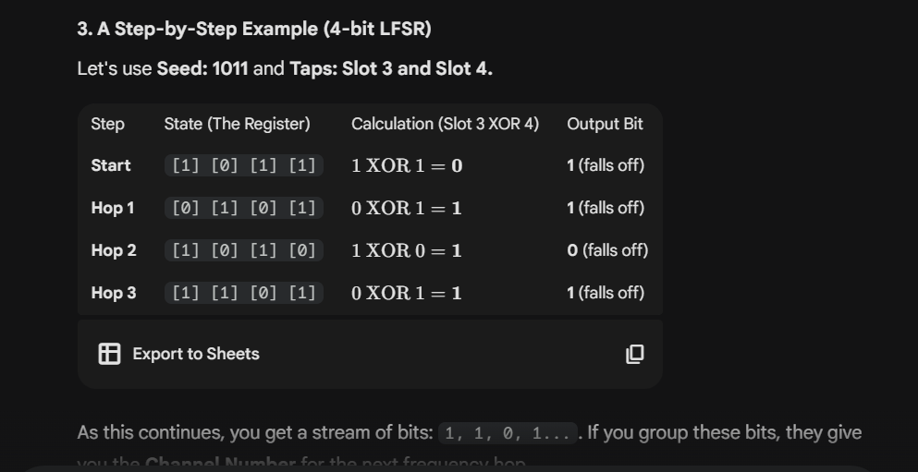

What if the control channel is itself jammed and we are not able to able to make the communication
- If the jammer is sensing the frequency sent by the transmitter
• The Transmitter: It doesn't know the control channel is jammed, so it just starts hopping through its 125 channels very fast (e.g., every 10ms).
• The Receiver: It stops trying to find the control channel. Instead, it sits on Channel 1 and waits for a long time (e.g., 500ms).
• The Intersection: Because 500ms is much longer than the time it takes the transmitter to cycle through all 125 channels, the transmitter will eventually "land" on Channel 1 while the receiver is listening.
• The Lock: The receiver hears one packet, grabs the Seed and Timestamp, and immediately joins the high-speed hopping sequence

- If the jammer is sending a destructive signal only at the control channel

The transmitter will continuously hop the frequency and the receiver will then choose a different frequency

